Assignment 4

Abi

2022-10-30

## Preparing DEA Analysis

## Required Packages

library(Benchmarking)

## Loading required package: lpSolveAPI

## Loading required package: ucminf

## Loading required package: quadprog

##   
## Loading Benchmarking version 0.30h, (Revision 244, 2022/05/05 16:31:31) ...

## Build 2022/05/05 16:31:40

Data <- matrix(c("Facility 1","Facility 2","Facility 3","Facility 4","Facility 5", "Facility 6",  
 150,400,320,520,350,320,  
 0.2,0.7,1.2,2.0,1.2,0.7,  
 14000,14000,42000,28000,19000,14000,  
 3500,21000,10500,42000,25000,15000), ncol=5, byrow=F)  
colnames(Data) <- c("DMU", "Staff_Hours_Per_Day","Supplies_Per_Day","Reimbursed_Patient_Days","Privately_Paid_Patient_Days")  
table<- as.table(Data)  
table

## DMU Staff_Hours_Per_Day Supplies_Per_Day Reimbursed_Patient_Days  
## A Facility 1 150 0.2 14000   
## B Facility 2 400 0.7 14000   
## C Facility 3 320 1.2 42000   
## D Facility 4 520 2 28000   
## E Facility 5 350 1.2 19000   
## F Facility 6 320 0.7 14000   
## Privately_Paid_Patient_Days  
## A 3500   
## B 21000   
## C 10500   
## D 42000   
## E 25000   
## F 15000

## Reading Input Data

Ip <- matrix(c(150, 400, 320, 520, 350, 320,  
 0.2, 0.7, 1.2, 2.0, 1.2, 0.7), ncol=2) # Defining inputs  
Op <- matrix(c(14000, 14000, 42000, 28000, 19000, 14000,  
 3500, 21000, 10500, 42000, 25000, 15000), ncol=2) # Defining outputs  
# Defining column names  
colnames(Ip) <- c("Daily Staff Hours", "Daily Supplies Cost")   
colnames(Op) <- c("Reimbursed Patient-Days", "Privately-Paid Patient Days")  
Ip

## Daily Staff Hours Daily Supplies Cost  
## [1,] 150 0.2  
## [2,] 400 0.7  
## [3,] 320 1.2  
## [4,] 520 2.0  
## [5,] 350 1.2  
## [6,] 320 0.7

Op

## Reimbursed Patient-Days Privately-Paid Patient Days  
## [1,] 14000 3500  
## [2,] 14000 21000  
## [3,] 42000 10500  
## [4,] 28000 42000  
## [5,] 19000 25000  
## [6,] 14000 15000

## Creating DEA Analysis Function

To avoid code repetition, let’s define a function that will perform the DEA under the given assumption.

Analyze_DEA <- function(assumption) {  
 analysis <- dea(Ip, Op, RTS=assumption)  
 print(eff(analysis))  
 print(peers(analysis))  
 print(lambda(analysis))  
}

After obtaining the DEA assumption to use, the function prints out the efficiencies, peers, and lambdas when we call it.

## Performing DEA Analysis

Now, in the following order: FDH, CRS, VRS, IRS, DRS, and FRH, we execute DEA on each of the six assumptions using the function we defined before.

## Free Disposability Hull

Analyze_DEA("FDH")

## [1] 1 1 1 1 1 1  
## peer1  
## [1,] 1  
## [2,] 2  
## [3,] 3  
## [4,] 4  
## [5,] 5  
## [6,] 6  
## L1 L2 L3 L4 L5 L6  
## [1,] 1 0 0 0 0 0  
## [2,] 0 1 0 0 0 0  
## [3,] 0 0 1 0 0 0  
## [4,] 0 0 0 1 0 0  
## [5,] 0 0 0 0 1 0  
## [6,] 0 0 0 0 0 1

## FDH observation

The DMUs are all effective. This is mainly because the FDH technique adheres to a certain principal, which allows it to identify even a very low level of efficiency.

## Constant Return to Scale

Analyze_DEA("CRS")

## [1] 1.0000000 1.0000000 1.0000000 1.0000000 0.9774987 0.8674521  
## peer1 peer2 peer3  
## [1,] 1 NA NA  
## [2,] 2 NA NA  
## [3,] 3 NA NA  
## [4,] 4 NA NA  
## [5,] 1 2 4  
## [6,] 1 2 4  
## L1 L2 L3 L4  
## [1,] 1.0000000 0.00000000 0 0.0000000  
## [2,] 0.0000000 1.00000000 0 0.0000000  
## [3,] 0.0000000 0.00000000 1 0.0000000  
## [4,] 0.0000000 0.00000000 0 1.0000000  
## [5,] 0.2000000 0.08048142 0 0.5383307  
## [6,] 0.3428571 0.39499264 0 0.1310751

## CRS Observations

We are able to observe the effectiveness of Facilities 1, 2, 3, and 4.

Additionally, we learn that the ineffective facilities Facility 5 and Facility 6 have Facility 1, Facility 2, and Facility 4 as peer members.

Facility 6 is 86.75% efficient, leaving 13.25% inefficient, while Facility 5 is 97.75% efficient, leaving 2.25% inefficient.

## Varying Return to Scale

Analyze_DEA("VRS")

## [1] 1.0000000 1.0000000 1.0000000 1.0000000 1.0000000 0.8963283  
## peer1 peer2 peer3  
## [1,] 1 NA NA  
## [2,] 2 NA NA  
## [3,] 3 NA NA  
## [4,] 4 NA NA  
## [5,] 5 NA NA  
## [6,] 1 2 5  
## L1 L2 L3 L4 L5  
## [1,] 1.0000000 0.0000000 0 0 0.0000000  
## [2,] 0.0000000 1.0000000 0 0 0.0000000  
## [3,] 0.0000000 0.0000000 1 0 0.0000000  
## [4,] 0.0000000 0.0000000 0 1 0.0000000  
## [5,] 0.0000000 0.0000000 0 0 1.0000000  
## [6,] 0.4014399 0.3422606 0 0 0.2562995

## VRS observation

We are given the opportunity to observe the effectiveness of Facilities 1, 2, 3, 4, and 5.

In addition, we learn that Facility 6, the alone inefficient facility,and its peer member of Facilities are 1, 2, and 5.

Facility 6 has an efficiency of 89.63%, leaving a 10.37% inefficiency.

## Increasing Return to Scale

Analyze_DEA("IRS")

## [1] 1.0000000 1.0000000 1.0000000 1.0000000 1.0000000 0.8963283  
## peer1 peer2 peer3  
## [1,] 1 NA NA  
## [2,] 2 NA NA  
## [3,] 3 NA NA  
## [4,] 4 NA NA  
## [5,] 5 NA NA  
## [6,] 1 2 5  
## L1 L2 L3 L4 L5  
## [1,] 1.0000000 0.0000000 0 0 0.0000000  
## [2,] 0.0000000 1.0000000 0 0 0.0000000  
## [3,] 0.0000000 0.0000000 1 0 0.0000000  
## [4,] 0.0000000 0.0000000 0 1 0.0000000  
## [5,] 0.0000000 0.0000000 0 0 1.0000000  
## [6,] 0.4014399 0.3422606 0 0 0.2562995

## IRS Observation

We are given the opportunity to observe the effectiveness of Facilities 1, 2, 3, 4, and 5.

In addition,Facility 1, Facility 2 and Facility 5 are the peer members for Facility 6 which is the only inefficient facility.

Facility 6 has an efficiency of 89.63%, leaving a 10.37% inefficiency.

## Decreasing Return to Scale

Analyze_DEA("DRS")

## [1] 1.0000000 1.0000000 1.0000000 1.0000000 0.9774987 0.8674521  
## peer1 peer2 peer3  
## [1,] 1 NA NA  
## [2,] 2 NA NA  
## [3,] 3 NA NA  
## [4,] 4 NA NA  
## [5,] 1 2 4  
## [6,] 1 2 4  
## L1 L2 L3 L4  
## [1,] 1.0000000 0.00000000 0 0.0000000  
## [2,] 0.0000000 1.00000000 0 0.0000000  
## [3,] 0.0000000 0.00000000 1 0.0000000  
## [4,] 0.0000000 0.00000000 0 1.0000000  
## [5,] 0.2000000 0.08048142 0 0.5383307  
## [6,] 0.3428571 0.39499264 0 0.1310751

## DRS Observation

We are able to observe the effectiveness of Facilities 1, 2, 3, and 4.

In addition, we learn that the ineffective facilities, Facility 5 and Facility 6, have Facility 1, Facility 2, and Facility 4 as peer members.

Facility 6 is 86.75% efficient, leaving 13.25% inefficient, whereas Facility 5 is 97.75% efficient, leaving 2.25% inefficient.

## Free Replicability Hull

Analyze_DEA("ADD")

## [1] 1 1 1 1 1 1  
## peer1  
## [1,] 1  
## [2,] 2  
## [3,] 3  
## [4,] 4  
## [5,] 5  
## [6,] 6  
## L1 L2 L3 L4 L5 L6  
## [1,] 1 0 0 0 0 0  
## [2,] 0 1 0 0 0 0  
## [3,] 0 0 1 0 0 0  
## [4,] 0 0 0 1 0 0  
## [5,] 0 0 0 0 1 0  
## [6,] 0 0 0 0 0 1

## FRH Observation

The DMUs are all effective. Because it adheres to the no convexity assumption, the output is protected against disposal and reproduction.

## Summary of Results (Inefficient DMUs)

Data.summarise.inefficient <- matrix(c("CRS","DRS","IRS","VRS","FDH","FRH",  
2,2,1,1,0,0,  
"Facility 5 & 6", "Facility 5 & 6","Facility 6", "Facility 6", "-","-",  
"97.75% & 86.7%","97.75% & 86.7%","89.63%","89.63%","-","-",  
"Facility 1, 2 & 4","Facility 1, 2 & 4","Facility 1, 2 & 5","Facility 1, 2 & 5","-","-",  
"0.2, 0.08, 0.54 and 0.34, 0.4, 0.13", "0.2, 0.08, 0.54 and 0.34, 0.4, 0.13", "0.4, 0.34 and 0.26", "0.4, 0.34 and 0.26", "-","-"),ncol=6,byrow=F)  
  
colnames(Data.summarise.inefficient) <- c("RTS","Count_Inefficient_DMUs","Name_DMUs","%_Inefficiency","Peers","Lambda")  
  
as.table(Data.summarise.inefficient)

## RTS Count_Inefficient_DMUs Name_DMUs %_Inefficiency Peers   
## A CRS 2 Facility 5 & 6 97.75% & 86.7% Facility 1, 2 & 4  
## B DRS 2 Facility 5 & 6 97.75% & 86.7% Facility 1, 2 & 4  
## C IRS 1 Facility 6 89.63% Facility 1, 2 & 5  
## D VRS 1 Facility 6 89.63% Facility 1, 2 & 5  
## E FDH 0 - - -   
## F FRH 0 - - -   
## Lambda   
## A 0.2, 0.08, 0.54 and 0.34, 0.4, 0.13  
## B 0.2, 0.08, 0.54 and 0.34, 0.4, 0.13  
## C 0.4, 0.34 and 0.26   
## D 0.4, 0.34 and 0.26   
## E -   
## F -

## Summary of Results (Efficient DMUs)

Data.summarise.efficient <- matrix(c("CRS","DRS","IRS","VRS","FDH","FRH",  
"Facility 1, 2, 3 & 4","Facility 1, 2, 3 & 4","Facility 1, 2, 3, 4 & 5", "Facility 1, 2, 3, 4 & 5", "All DMUs", "All DMUs"), ncol = 2, byrow=F)  
colnames(Data.summarise.efficient) <- c("RTS", "Efficient_DMUs")  
as.table(Data.summarise.efficient)

## RTS Efficient_DMUs   
## A CRS Facility 1, 2, 3 & 4   
## B DRS Facility 1, 2, 3 & 4   
## C IRS Facility 1, 2, 3, 4 & 5  
## D VRS Facility 1, 2, 3, 4 & 5  
## E FDH All DMUs   
## F FRH All DMUs

Under all six assumptions, facilities 1, 2, 3, and 4 are considered efficient, and without the assumption of convexity all six facilities are efficient.

Under the VRS and IRS assumptions, facility 6 is inefficient. Its peers are facilities 1, 2, and 5 with $λ_{1}^{6}=0.401$, $λ_{2}^{6}=0.342$, and $λ_{5}^{6}=0.256$.

Under the CRS and DRS assumptions, facilities 5 and 6 are both inefficient. The peers of both facilities 5 and 6 are facilities 1, 2, and 4, with $λ_{1}^{5}=0.2$, $λ_{2}^{5}=0.080$, $λ_{3}^{5}=0.538$, $λ_{1}^{6}=0.343$, $λ_{2}^{6}=0.395$, and $λ_{3}^{6}=0.131$.

## Plotting Graph

## FDH Plot

dea.plot(Ip,Op,RTS="FDH")

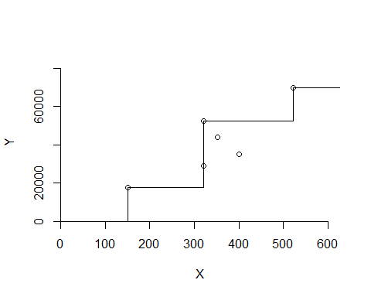

## VRS Plot

dea.plot(Ip,Op,RTS="VRS")

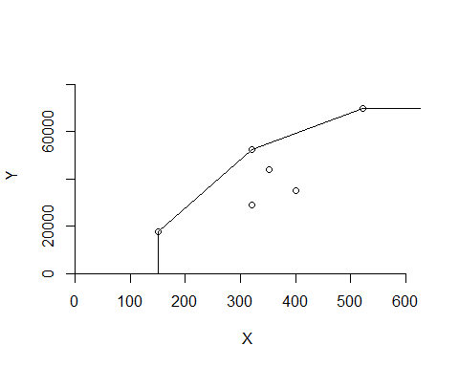

## CRS Plot

dea.plot(Ip,Op,RTS="CRS")

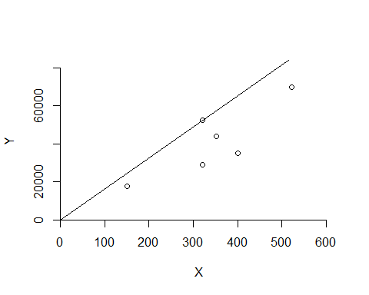

## ADD Plot

dea.plot(Ip,Op,RTS="ADD")

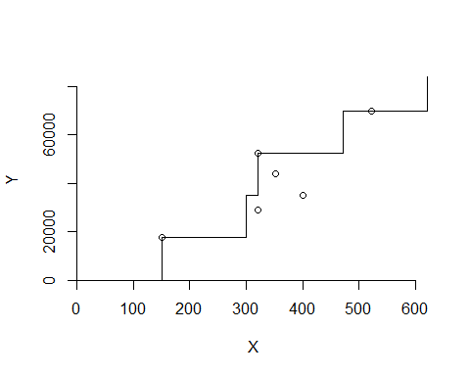

DRS Plot

dea.plot(Ip,Op,RTS="DRS")

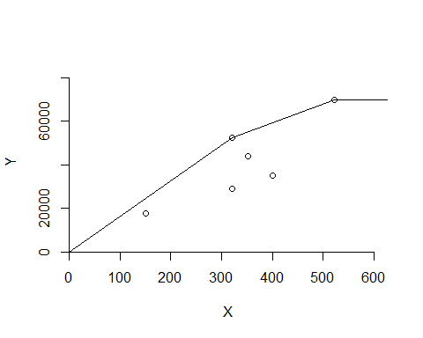 IRS Plot

dea.plot(Ip,Op,RTS="IRS")

